CURRICULUM VITAE

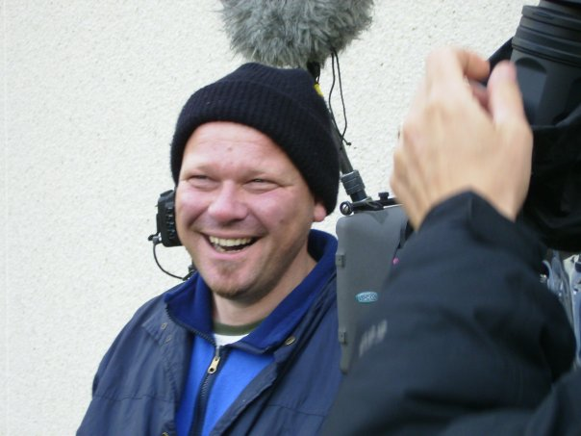
NAME Árni Gunnarsson
ADRESS Vidihlid 14
550 Saudarkrokur
DATE OF BIRTH Born 15. april 1967

TEL. 00354 4557005
MOBIL 00354 892 7707
E - MAIL arni@skottafilm.com

RESUME
As a teenager and in my highscholl yearsI worked on a farm, in constuction, bulding roads, in slaghterhouse, in supermarket, as a professional foxhunter and as a Guid for foreighn tourist.

From 20 – 29 I worked mainly as a reporter for newspapers and radiostations in Iceland, but also as a production manager in media production. In my 30 I was hierd as a political advisor for the minister of social affairs in Iceland and worked on that field for the next 3 years. For the next ten years I was chairman of the Refugie Council in Iceland and after I quited as a political advisor I was working as a advicer and consultant for small and medium compalies.

I promoted my own filmmaking company, Skottafilm, in 2004. My occupation to day is as a producer and manager for Skottafilm.

EDUCATION
MA Gymnasium, Akureyri. 1983 - 1987. Student.
Uni Iceland, Reykjavík 1989 – 1992. Histroie.
Uni Bielefeld, Germany. 1992 – 1993. Historie.
Kort- og Dokumentar Filmskolen, Copenhagen. 2007 – 2008. Filmmaking.

Filmographie

Í Austurdal (In Austurdalur) 2004. Documentary (47 min. DV PAL 16:9) Premiere on RUV (Icelandic State TV) on easter evening 2005. Island Film (German Film Festival) 2008.

Að komast í flugvél (The way out of the Balkans) 2005. Documentary (30 min. DV PAL 16:9) for TV. Premiere on RUV (Icelandic State TV) 2006.

En Lille Smule Dansk 2007. Short Film (10 min. DV PAL 16:9). Kort- og Dokumentar Filmskolen in Chopenhagen.

Þættir úr sögu Íbúðalánasjóðs (Aniversary Film for the House Bank in Iceland) 2008. Documentary (32 min. PAL 16:9). Premiere on INN 2008.

Dansað á fáksspori (Dancing with horses) 2009. Four 22 min. long TV shows for RUV (Icelandic State TV) (DV PAL 16:9).

Kraftur – The Last Ride 2009. Documentary (47 min. HD Cam 16:9 sterio mix). Premiere on Gimli Film Festival 2009. SAM Cinemas Reykjavík 2009.

