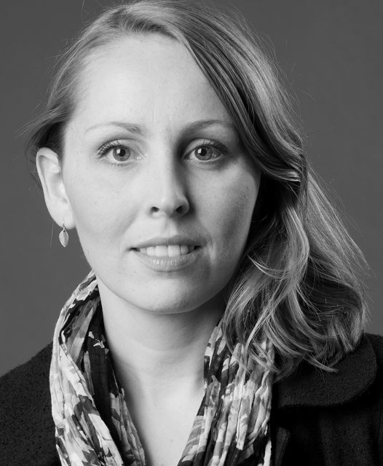
PRODUCER
Kristin Andrea Thordardottir
BIO

Kristin studied International Business (B.Sc. 2004) and Marketing Communications Management (M.Sc. 2006) at Copenhagen Business School. She joined Poppoli Pictures at the start of 2007 and has worked with director and founder Olaf de Fleur ever since on his productions and developments as producer and head of production. She also founded her own small production company to produce her own independent and commercial projects.

City State (feature in post production) Poppoli Pictures (2011)
Adequate Beings (documentary in post production) Poppoli Pictures (2011)
Polite People (feature in post production) Poppoli Pictures (2011)
Undying Love (short in post production) Poppoli Pictures (2011)
Brú til borgar (documentary in post production) Jadar Pictures (2011)
Circledrawers (webisodes) Poppoli Pictures (2009)
The Amazing Truth about Queen Raquela (feature) Poppoli Pictures (2008)
Higher Force (feature) Poppoli Pictures (2008)

