SNORRI THORISSON CV

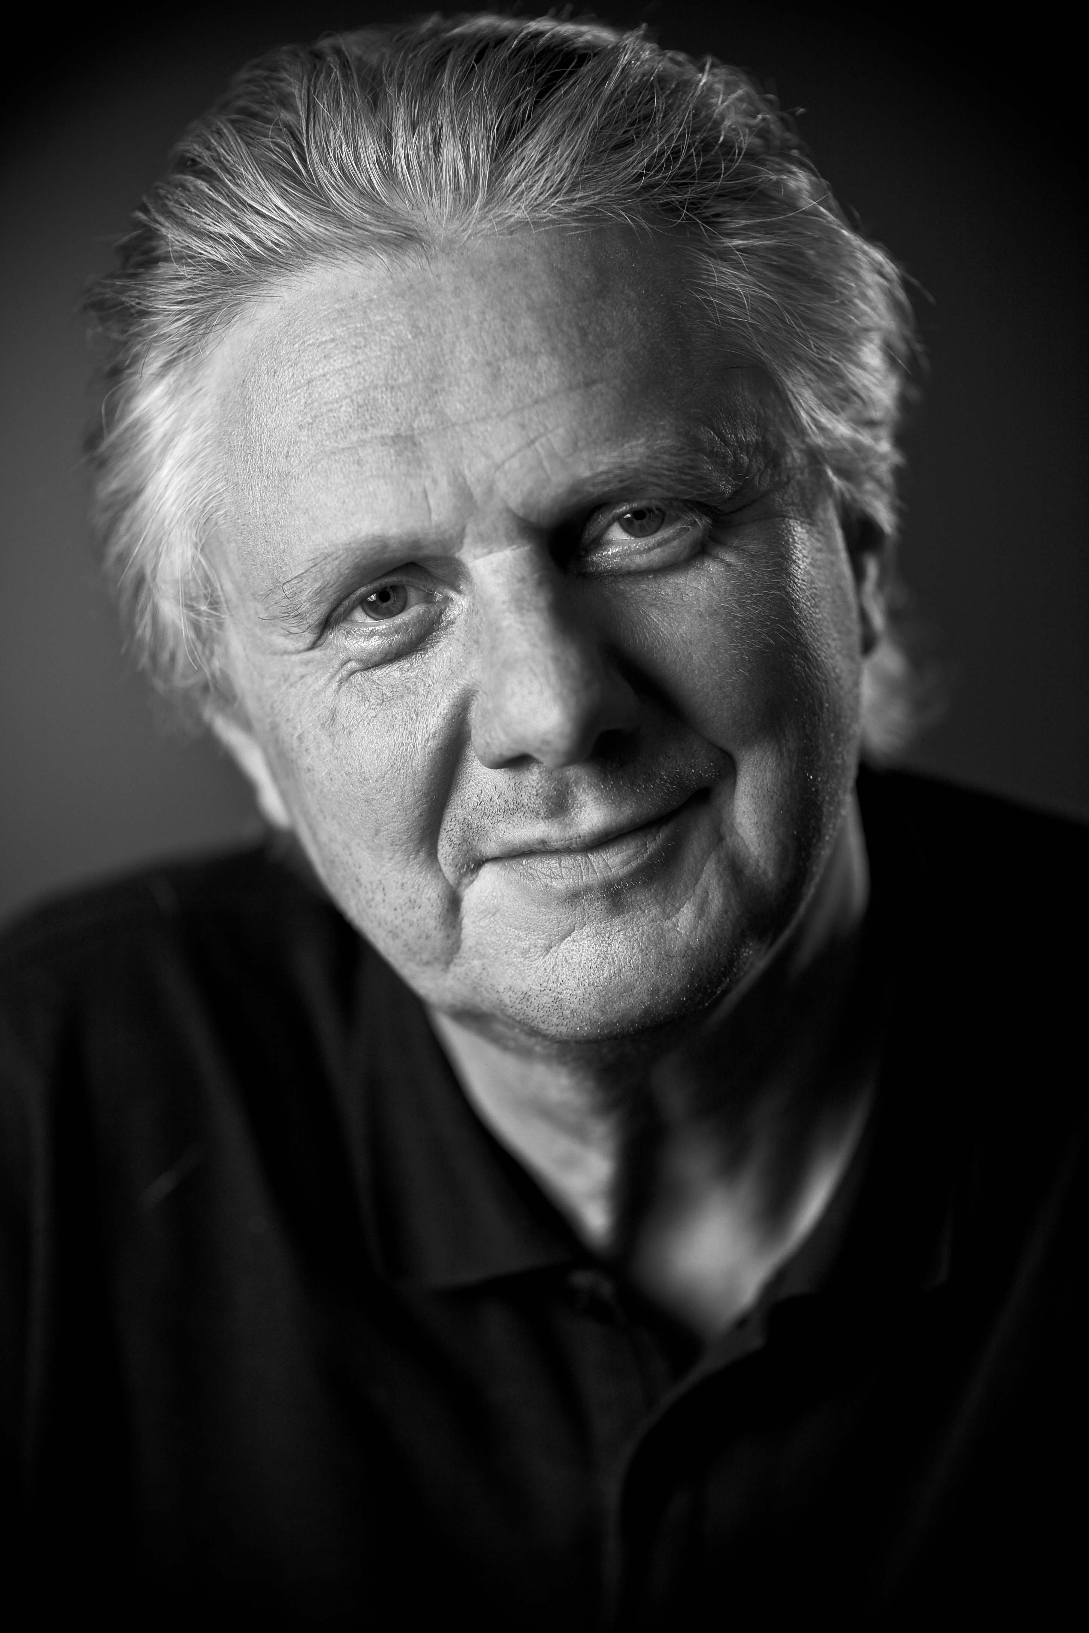
Snorri Thorisson has been a leading name in the filmed entertainment industry in Iceland for over 30 years. He has filled most key industry positions including Producer, Director of Photography, Writer, and Film Editor, Snorri is a recipient of the prestigious Nordic Amanda Award, for his work behind the camera.
Snorri set up Saga Film in 1979. Under his chairmanship the company grew to be a thriving production house, producing TV programs, commercials and features, such as The House and Father’s Estate, seen by a third of the Icelandic nation.
In 1992 Snorri sold the company and went on to establish Pegasus Pictures, now a leading production house in Iceland with a complete workflow for the 4k RED, including color grading and Digital Cinema Mastering. In association with Arri Media Pegas Pictures is the main provider of rental equipment for the local film industry.
Snorri is developing dramas and feature films with young directors and writers as well as working with establisher writers and directors, while his most recent production Rokland is in post production, using the new digital technique.
He is the National Coordinator of the EAVE (les Entrepreneurs de l’Audiovisiel Europeén) training program in Iceland and a member of the Icelandic Film Producer’s Association where he served as chairman for a number of years.

Some of Snorri’s Producing Credits, include:

Rokland (2010) 100 min feature film to be premiered in Decenber 2010

Rót 30 min short film, Directed by Isold Uggadottir. (in production).

The Cliff (2008-9) 4 x 52 min drama series and 2x90 min. Directed by Reynir Lyngdal.

The Symphony Orchestra in Berlin. ( 2008) 30 min TV program

Heiðin (2007) 90 min feature film. Directed by Einar Gunnlaugsson

O7/08 (2007-8) 20 x 30 min weekly TV program, aired on RUV

Aramotaskaup (2006) 60 min drama program directed by Reynir Lyngdal.

Thicker Than Water (BlÓÐBÖND) (2005) 90 min feature Co-Produced with Zentropa Entertainments and Thalamus Film GmbH. Directed by Arni Olafur Asgeirsson.

The Magician (2005) 15 min short. Directed by Reynir Lyngdal

Kisses 5min short produced for the EFA directed by Reynir Lyngdal

Virus In Paradise (2003) Directed by Olivier Langlois. A co-production with Cipango, France and GotaFilm, Sweden. Starring Richard Bohringer

Anna’s Day (2003) 30 min short film directed by Arni Ólafur Ásgeirsson.

