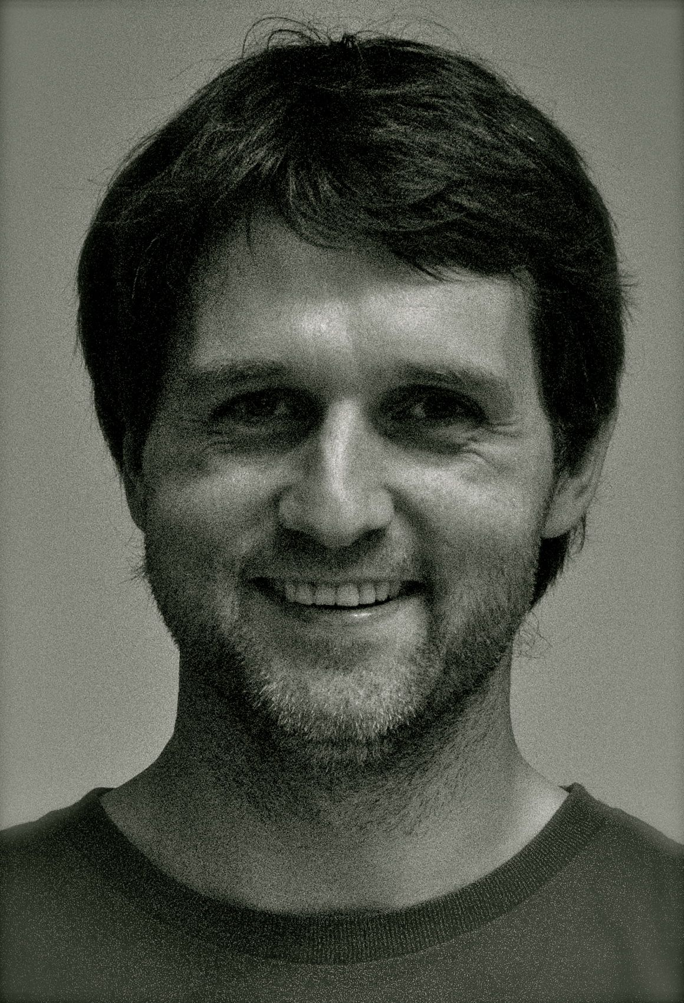
DIRECTOR
GUDNI PALL SAEMUNDSSON
BIO

Gudni has worked in film since his early twenties. He is a Vancouver Film School graduate in film production and directing since 2006. He and director Olaf collaborated closely on Adequate Beings as a directors team. Previously Gudni has worked with Olaf as assitant director on the features The Higher Force (2008) and The Amazing Truth about Queen Raquela as well as two features set for release in 2011 Polite People and City State. Gudni also directs and produces his own industrials and documentaries in collaboration with producer Kristin Andrea Thordardottir through their production company Jadar Pictures founded in 2007.

